

217, Sheikh Rashid Building

P.O Box 56272, Dubai

United Arab Emirates

Tel: +971 4 2973236 / 04 2974007

Email: uae@verbat.com

TECHNICAL   
PROPOSAL

**DAMAK Properties Conference Application**

|  |  |
| --- | --- |
| **Prepared for:**  DAMAK Properties | **Submission Date:**  25 Aug 2017  **Proposal ID:** WD/25082017/1343/3 |

___________________________________________________________________________________________________________________________________________  
Conﬁdentiality Notice: This Proposal is conﬁdential and contains proprietary information and intellectual property of Verbanet Technologies LLC. Neither this proposal nor any of the information contained herein may be reproduced or disclosed under any circumstances without the express written permission of Verbanet.

© 2017 by Verbanet Technologies LLC. All rights reserved. Confidential.

___________________________________________________________________________________________________________________________________________

|  |  |
| --- | --- |
| Client Information | |
| Project Name | Hybrid and Web Conference Application |
| Client Name | DAMAK Properties |
| Client Address | Tender Committee  Hutchison Ajman International Terminals Limited – F.Z.E.  P.O Box 388  Ajman, United Arab Emirates |
| Phone Number | +971 6 7470 111 |
| Fax Number | +971 50 482 3360 |
| Verbat Information | |
| Contact Person | Joyce Daniel |
| Contact Person Phone Number | +971 4 2973236 |
| Contact Person E-Mail | Joyce.daniel@verbat.com |
| Address | PO Box 56272, Dubai |
| Physical Address | Flat 217, Sheik Rasheed Building, Hor Al Anz East, Dubai |
| Project Information | |
| Proposed Technology/Methodology | PHP , MySQL |
| Anticipate Start Date | 29 June 2017 |
| Proposal Valid For | 120 Calendar days from the submission of the proposal |

Project Contacts

**Table of Content**

1 Executive Summary 5

1.1 Proposed Solution Model 5

1.2 Solution Objective 6

1.3 Advantages of Proposed Solution 7

1.4 Why Verbat 8

1.5 Key Differentiators 9

1.6 Underlying Support Services 10

2 Functional Specification 11

3 System Architecture 13

4 Functional Architecture 14

5 Hardware Architecture 15

6 Non Functional Requirements 16

7 Assumptions 16

8 Out of Scope 18

9 Technology Solution 19

9.1 Technical Configuration 19

9.1.1 Development Tools 19

9.1.2 Browser Compatibility for Web Admin 19

9.1.3 Hardware Interface 20

10 Delivery Management 20

10.1 Project Management 20

10.2 Roles and Responsibilities 20

10.3 Delivery Activity summary 21

10.4 Project Implementation plan 21

10.5 Deliverables 21

10.6 Estimated Delivery Time for Website Development 22

10.7 Deployment Details 22

10.8 Release Planning 22

10.9 Risk and Contingency planning 23

11 Change Management 24

12 Miscellaneous 25

12.1 Acceptance Criteria 25

12.2 General Terms and Conditions 25

12.3 Assumptions and Dependencies 26

12.4 Source Code & Intellectual Property Rights 27

12.5 Maintenance & Support 27

12.6 Our Clients 29

# Executive Summary

**DAMAC properties** (Here after knows as “The Client”), a leading property development company, based in Dubai is in need of a **web conference** solution, their goal is to:

1. Establishing a new touch point/platform for customers to reach out to DAMAC properties
2. Host one to one meetings between sales team and prospective clients by minimizing the need to physically travel
3. Web conferences which support dialogue between two parties via chat (text), Call (VOIP) and Video
4. Integration with existing CRM solution for seamless lead allocation to sales team and tracking

The objective of this RFP is to locate a source that will provide the best overall value to DAMAC properties.

Web & Mobile Development is an area where Verbat has in-depth knowledge and expertise. Being the pioneers in Web based and Mobile based solutions across the major verticals, we are sure to help you enhance your customer engagement to drive differentiation. We bring proven methodologies and processes, global expertise in development, and a legacy of best practices and ready-to-fit frameworks to expedite the development cycle and reduce the total cost of ownership.

Verbat is pleased to have received the request to submit the proposal and values it as a great opportunity to have a long term & mutually beneficial association with the client. Verbat has gone through the requirement and presents a technical proposal for the requested system

## Proposed Solution Model

Stand-Alone Fixed Bid

Verbat will be following a stand –alone fixed bid solution delivery model wherein the required solution would be devised and a suitable pricing would be offered.

## Solution Objective

The client has contacted Verbat Technologies to develop a new Content Management System based web site using the latest technologies and design trends. The new website shall have the following features

* The solution seeks to minimize the need of physically travelling to locations across the globe to access buyers who are interested in buying properties with DAMAC.
* The solution seeks to provide on the go solution to both sales team and buyers by giving access on smart phones as well as desktops
* Solution should enable document sharing to assist sharing of project details, cost sheets, available inventory etc.

A graphical representation of process flow is as below: The scope of the overall system includes:

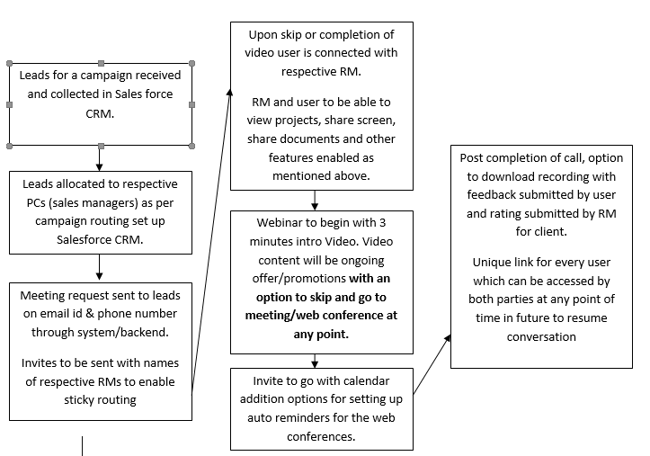

The proposed solution will be completed in 2 phases

**Phase 1**

1. Access the CRM to retrieve leads
2. Send invites to leads
3. Invites received by email or on the hybrid app
4. Client clicks on the email invite and the meeting will be scheduled
5. Alternatively they may join the web conference via a separate link
6. Client accepts the invite through the hybrid app
7. Invite gets scheduled in his mobile app
8. Client joins the meeting using the mobile app
9. Video archived to be viewed later

**Phase 2**

1. Sharing whiteboard
2. Link based push notifications
3. Screen Snapshots
4. Dial IP Phone
5. Polls & Surveys
6. Backend Dashboard with reports for managers
7. Round robin call allocation logic; Call routing & sticky routing logic
8. Calendar addition for web conference or invite reminders synched with outlook, google etc.
9. Sharing of documents and slide shows
10. 3 minute Intro video before meeting begins
11. Submit feedback
12. Unique link to resume conversation in the future (extend token expiration)

**The main features of the Web App are listed below:**

* Allows slideshow presentations
* Enables calling through VOIP
* Meeting recording available to both the parties
* Provision for whiteboard functionality
* Communication via Text/chat,
* Polls and Surveys – Feedback /rating mechanism post the web conference
* Screen and application sharing only
* Compatible across Linux, Windows, MAC OS and Android platforms
* HD and VGA video quality supported for video conference depending on the internet connection speed
* Option of dial by phone also available
* Allow showcase of hybrid events apart from one on one conversations
* Link based push notifications to launch the software on client side with no need for pre-installation of any software
* Cloud based software to run as web based application relying only on WebRTC and not Java or Adobe flash. Should preferably allow the web conference host to install and run the software on its own local servers.
* Allow screenshots and sharing
* Allow sharing of documents, videos and pictures over chat console
* To enable functionality difference between presenter and attendees
* To be enabled on smart phones and desktops
* No pricing, product and usage cost for both hosts as well as attendees
* Backend support with user dashboard with daily and weekly reports for managers
* Automatic logic for call routing mechanisms amongst set of sales managers. Logic built in with sticky routing and round robin based call allocation
* Calendar addition option for enabling reminders for web conferences. Invites synced with Google calendar, Facebook calendar, Outlook calendar etc.

Verbat’s Solution architects have conducted a thorough research on the requirements and have come to the conclusion that our proposed solution, which is detailed further in this document, will meet the requirements put forth by the client. And the proposed solution will be delivered in a phased approach as per Verbat‘s managed solution model.

**Strong and Scalable platform:** The platform proposed will be strong and scalable enough to accommodate future enhancements.

**Accelerated solution:** The framework would act as a solution accelerator. It would provide the basic building blocks which could be reused in future for building new components and features as part of enhancements

**High performance:** The light weight framework used consumes fewer system resources thereby making the application perform faster

* System shall be available 24/7
* System shall be performant without any lags or delays

**Security:** The application will be developed considering various aspects of security

## Advantages of Proposed Solution

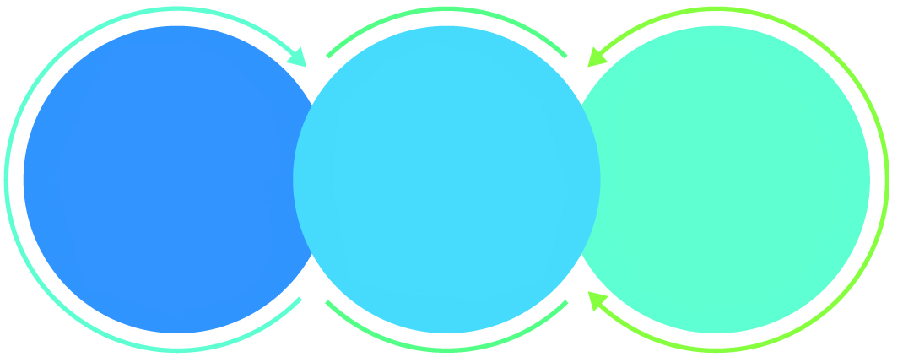

01

Agile development offering reliable, scalable and secure solution

02

Smooth transition and quicker completion of processes

03

User friendly interfaces enabling easy navigation between screens

## Why Verbat

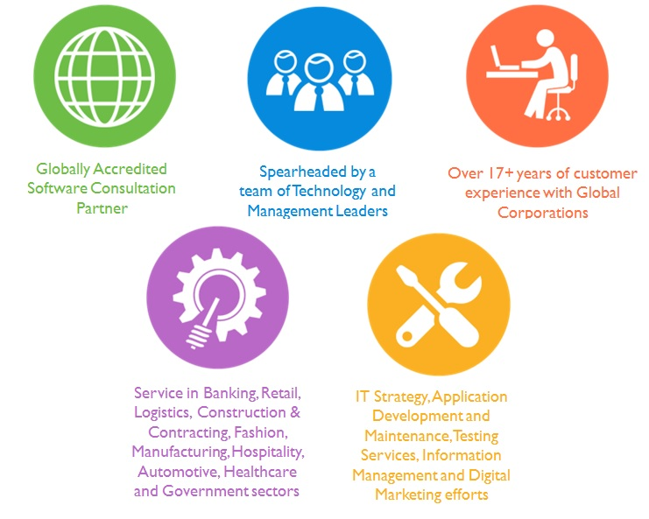

## Key Differentiators

Delivered digital transformation expertise to global customers for over a decade by following industry best practices to maximize ROI for client

Keen technology intelligence combined with aggressive market research to deliver solutions that achieve results with measurable value

Enable access to global consulting expertise with strong local market and business knowledge

Commercial Model that is customizable for your business needs

Services that are designed to optimize applications for improved performance and overall efficiency

1,000,000 plus man-hours of expertise in technology frameworks spanning Microsoft, Open Source, mobility platforms and other proprietary IT technology

Partners top technology vendors to bring in the latest and best services in integration, collaboration, and development

Commercial Model that is customizable for your business needs

Proven Methodologies & Processes

Investment in R & D

Strong Local Presence

Flexible commercial Models

Technology Associations

Software Development Experience

Offshore Development Centre

Quality Assurance & Testing

## Underlying Support Services

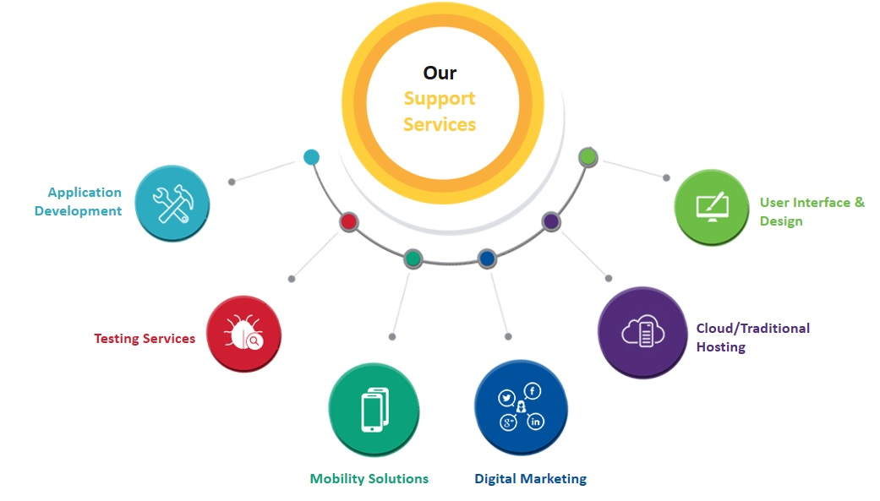

# Functional Specification

The proposed application will be developed in 2 phases. Functional specs for the application is detailed below.

## Phase 1

|  |
| --- |
| **Client side web integration** |
| Get session ID and token from server |
| Connect to the session using token |
| Publish audio/video streams |
| Subscribe to audio video stream |
| listen for session events |
| Set Up SDK and framework |
| **Server side integration with Web service** |
| Set up server side SDK and application framework |
| create sessions in app cloud |
| generate tokens for client (Unique URL invite to join the meeting) |
| send sessions IDS & tokens for clients |
| **Sessions** |
| create chat room session |
| Connect clients to one another |
| send events to clients |
| **Web Client** |
| Authentication / requesting permissions |
| connecting to session and creating publisher |
| initializing subscriber |
| CSS customizations |
| Publishing streams to subscriber |
| subscribing to other client streams |
| Adjusting Audio and video |
| Customizing UI |
| Session Monitoring |
| Moderation |
| **Screen Sharing (HTTPS Mandatory)** |
| Checking for screen-sharing publishing support |
| Publishing a stream with a screen-sharing source |
| Setting the maximum resolution of the stream |
| Cropping or letter-boxing screen-sharing videos |
| Determining the video type ("screen" or "camera") for a stream |
| Detecting when video dimensions change |
| Determining when the user stops sharing the screen |
| Subscribing to screen-sharing streams |
| Develop Chrome screen sharing extension |
| Distributing extensions |
| **Text Messaging** |
| Signaling |
| signal payloads |
| Signal delivery |
| **Other Features** |
| Archiving |
| SIP Inter connect Internet telephony (VOIP) |
| Integration with CRM Application (Send email invites to leads) |
| URL encoded meeting invite that uniquely identifies the lead |
| Exception Handling |
| Debugging |
| Account management |
| Security |
| **Hybrid app** |
| Configure OpenTok SDK with Cordova |
| Migration of Web Application to Hybrid App @ 4.5 hrs. / page (avg 10 pages) |

**Phase 2**

|  |
| --- |
| **Mobile + Web integration** |
| Whiteboard Sharing |
| Link based push notifications |
| Screen shot sharing |
| Dial IP Phone |
| Polls & surveys |
| backend dashboard with reports for managers |
| Automatic logic for call routing |
| Sticky routing |
| Round robin based call allocation |
| calendar addition for web conference or invite reminders synched with outlook, google etc. |
| Sharing of documents and videos over video chat |
| 3 minute Intro video before meeting begins |
| Submit feedback |
| Unique link to resume conversation in the future |
| Enable slide shows or share documents |

# System Architecture

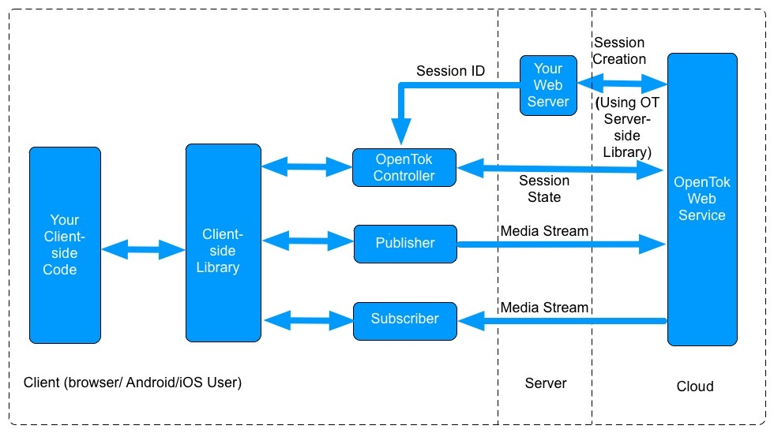

A stream is a single audio-video signal, which includes a User’s published webcam and microphone feed.

A connection is a logical abstraction of a single browser tab’s interaction with a session. The connection is a mechanism through which a browser publishes and subscribes to streams within a session.

A session represents an entire video chat environment. It is a collection of connections publishing and subscribing to streams. At a higher level, one can think of a session as a virtual video chat room.

OpenTok architecture is consists of client-side libraries (for JavaScript, Android and iOS) and the OpenTok server SDKs. The OpenTok API platform is based on three important concepts: streams, Connections and Sessions.

# Application Sequence Diagrams

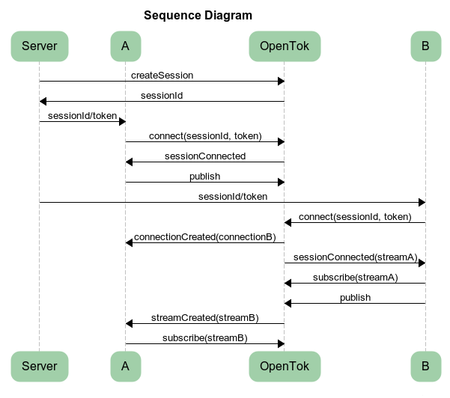

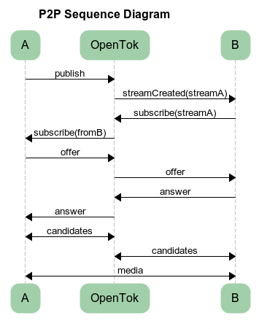

# Application Workflow

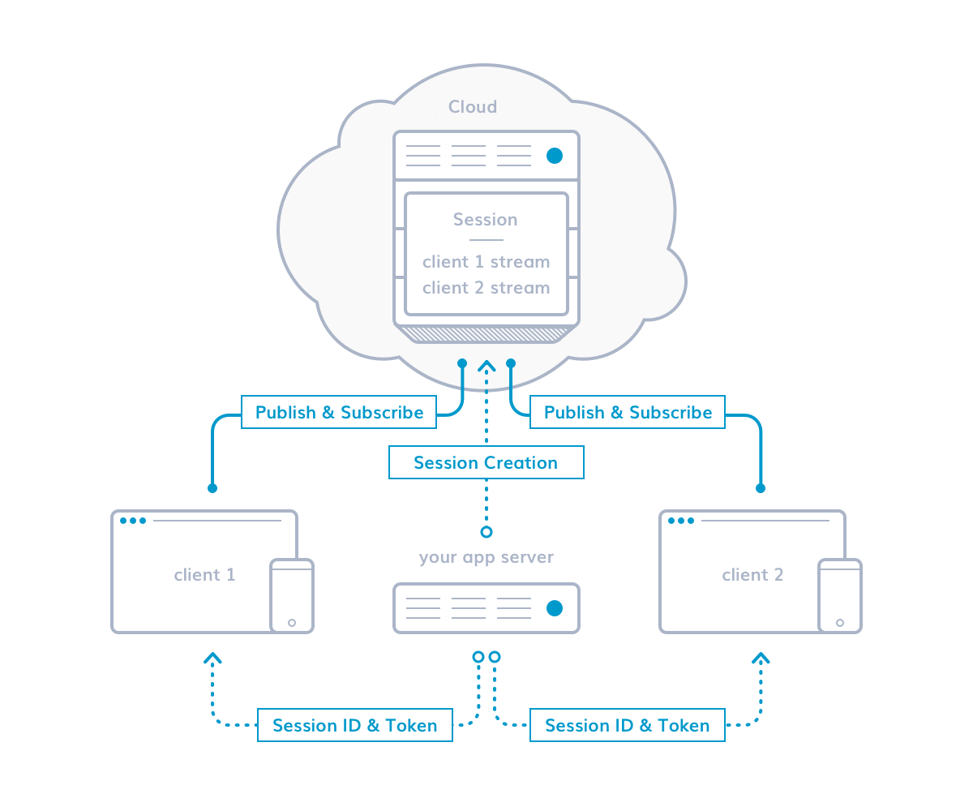

**The Client** — client-side code that runs in a browser or mobile app, set up by the developer using the OpenTok client-side libraries, which are available for Web, iOS, and Android. The client-side handles the majority of functionality.

**The Server** — server-side code executed on a web server set up by the developer using the server SDKs, which are available for Node, PHP, Java, .NET, Python, and Ruby.

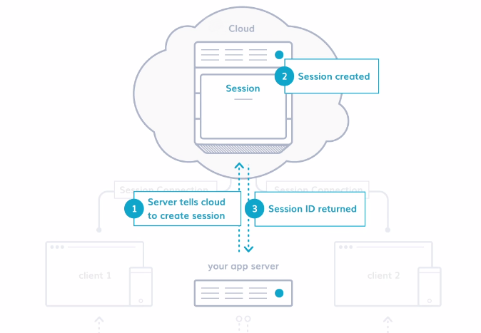

Figure 1 Session is being created by our application server

The application server (being developed), using code from an OpenTok server SDK, creates a session in the cloud via the OpenTok REST API and receives the session ID. Session can be thought of as a “room” where the video chat will occur. At this point it is unoccupied.

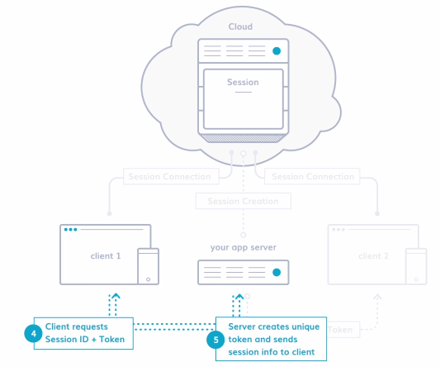

Figure 2: A client loads the app and server creates a token

When a user loads your client-side application, built with an OpenTok Client SDK, the client (a web page or mobile app) gets session info from the server. This includes a unique authentication token (the client’s “key”) created by your app server.

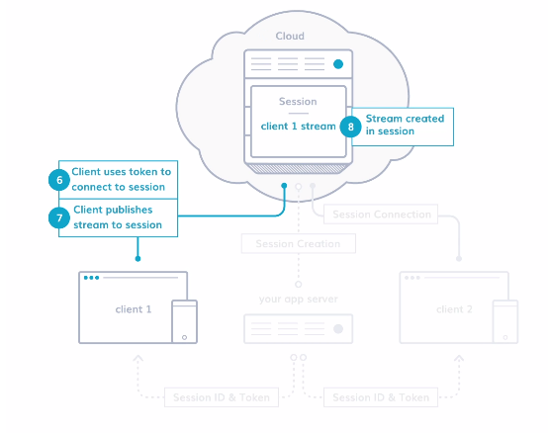

Figure 3: The client connects and begins streaming to the session

The client uses the session ID and token to establish a connection with the session. The client can then publish an audio-video stream to the session and listen for important events (such as a new user joining the session). At this point, the client is the only participant in the session.

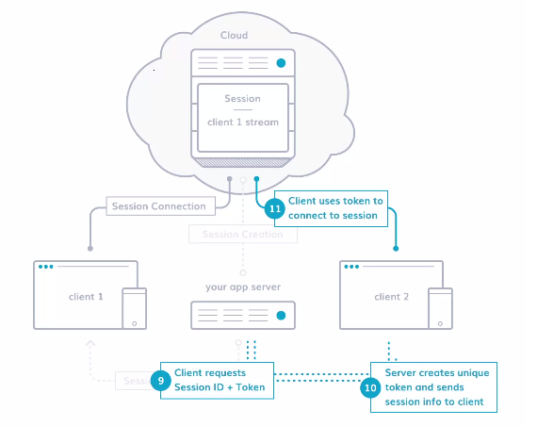

Figure 4: A new client connects to the session

When a new user loads the client-side application in a separate web page or mobile device (Client 2), the new client receives the session ID and a unique token from your app server. The client uses that info to establish a connection to the session.

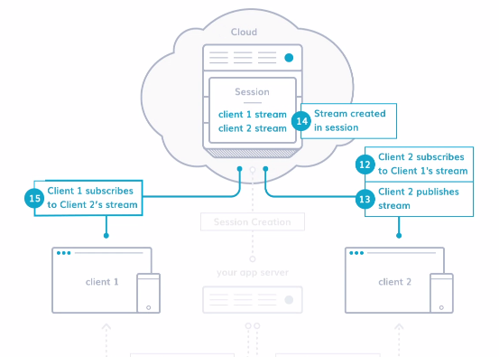

Figure 5: The clients subscribe to each other’s streams

Now that it’s connected to the session, Client 2 can subscribe to Client 1’s stream. Client 2 then publishes its own video stream to the session, and Client 1 subscribes to it. Both clients are now subscribed to each other's stream in a one-to-one video chat, and both are “listening” for new events (such as a new user connecting the session.)

# Non Functional Requirements

|  |  |
| --- | --- |
| **Requirement** | **Details** |
| User Experience and  UI Design | * The website will be developed only in English, Arabic and Chinese * The layout and graphical components will be created considering the usability factors |
| Performance | * Website will allow users to have smooth and quick access to the information or services they require. |
| Security | * The system will be protected against attempts of security breaching that may arise. * Web security standards will be followed. |

# Assumptions

The project solution and technology is created from the initial understanding of the requirement shared with Verbat through mails and meetings. The proposed solution is based on the following assumptions:

1. Design:

* Client to provide Verbat with the branding guidelines.
* The proposed Website front end and backend would be developed in English
* Verbat is free to use custom made template for design, if required.
* Client shall provide licensed images and logos in specified size & format

1. Development:

* Requirements should be well defined, agreed and signed-off by the client
* Internet connectivity is required for the functioning of the website.
* Color theme shall be provided by the client
* Client shall provide licensed images and logos in specified size & format
* Client shall provide the text and associated images
* Client shall purchase SSL certificates
* Application and data backups are subject to the purchase of such services at an extra cost
* Client will host and manage the application on infrastructure recommended by Verbat for managing database and application backup
* SIP Gateway for internet telephony will be purchased by the client
* Opentok media router will be utilized for call routing and this service will be procured by the client
* Archiving for saving audio & video will cost @$0.035 per minute (Rate varies based on volume)
* SIP Interconnect @ $0.005 per minute (Rate varies based on volume)
* Opentok framework usage cost 9.99 / 2000 minutes
* Archiving, SIP interconnect & Framework usage prices are ongoing expenses throughout the life time usage of the developed application. These expenses are to be tendered to TokBox the parent company of OpenTok
* HTTPS is mandatory for sharing files and will be provided by client
* OpenTok Services shall be acquired by client
* Apple and Android Store deployment & testing license will be procured by the client
* Verbat will need 1-2 weeks to mobilize resources, Project planning etc.

# Out of Scope

With the ever evolving digital market, the requirement needs should be clear to both the parties involved, hence the importance of mentioning the out of scope details of the project. Following are considered to be out of scope while creating this proposal.

* Purchase of images, fonts
* Adding new features to the application other than mentioned in this proposal
* Any language other than English, Arabic & Chinese
* Integration with any third party system including payment/ SMS gateway and Clients Internal Systems
* Manual data entry
* Database migration
* Content writing
* Audit Trail
* Annual Maintenance Contract (Bug fixing, debugging) – Please refer section 12 titled as “Change Management”.
* Physical deployment at client’s site
* Content or image procurement or uploading or editing
* Hosting Infrastructure and Maintenance
* Hardware Integrations / procurement and purchase
* Backup solution and Disaster recovery.
* Data Replication

# Technology Solution

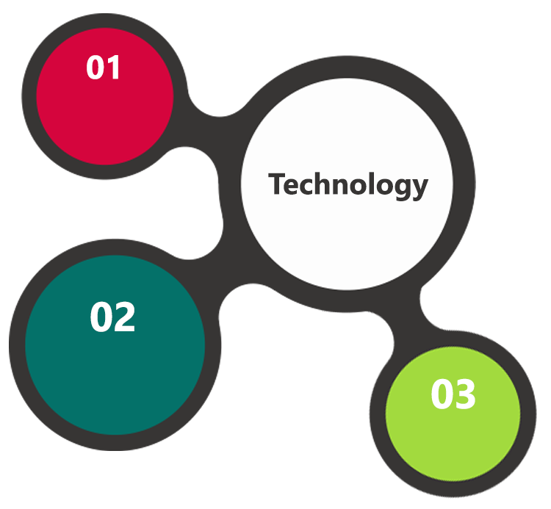

ASP.Net 4.5

MVC, C#, Cordova

MSSQL  
Windows 2012 OS

SSL

HTML 5  
JavaScript  
CSS3

A major portion of the application will be developed using Microsoft technology employing a mix of web services and web interfaces to configure the application.

## Technical Configuration

### Development Tools

* Visual Studio
* Server Management Studio & Photoshop
* Cordova for hybrid application development

### Browser Compatibility for Web Admin

* Chrome 56.0
* Firefox 51.0
* Internet Explorer 11

### Hardware Interface

The application is reliant on hardware interfaces to provide a seamless automated user experience.

* Computer with Windows 8 or 10 OS
* MSSQL Server

# Commercials

## Web Application

|  |  |  |
| --- | --- | --- |
| **No** | **Description** | **Amount (USD)** |
| 01. |  | 00,000.00 |
| 02. |  | 00,000.00 |
|  |  |  |

*Note:*

* *The above cost does not include Application hosting, integration, Project Management or deployment*
* *For change management cost, please refer to section 10 titled Change Management*

## Payment Terms

*Note: Payment should be made within 7 days from the date of the invoice*

## Mode of Payment

By Cheque / DD to Verbanet Technologies LLC

OR

Wire transfer to our bank account

Bank Name : Emirates NBD

Account Name : Verbanet Technologies LLC

Account Number : 1011492858201

IBAN Number : AE61 0260 0010 1149 2858 201

Swift Code : EBILAEAD

Bank Address : Mamzar Branch, Dubai

*Note: Bank charges incurred during wire transfer to be borne by the client. Any local taxes applicable to be borne by the client*

# Delivery Management

## Project Management

The Verbat development center strictly follows industry standards on quality. The project management is process governed by the Verbat Quality Management system and is put to verification through internal audit programs that happen from time to time.

Verbat will dedicate a project manager for the proposed implementation. Verbat proposes Client to identify one project manager who will be driving activities to be undertaken by Client to be the single point of contact for Verbat.

Verbat is a community of strong Agile practitioners. We follow the scrum methodology for project management and delivery. Verbat recommends clients to procure a JIRA license for the duration of the project. This will enhance and facilitate smooth communication for both parties. More importantly clients will be able to track the progress of the project on a daily basis.

In addition to this Verbat will communicate with the client on a daily basis the progress of the project along with perceived bottlenecks. We also conduct standup meetings on a daily basis with the project stakeholders. We strongly believe in effective communication so as to keep our clients abreast on every aspect of the project progress. Hence we are willing to accommodate any other additional effort that would alleviate the comfort level of our clients. Weekly and monthly status meetings and mails along with definition of done are assumed by default.

## Roles and Responsibilities

Verbat will assign a dedicated Project Manager/Project Lead to lead the project, who will be the first point contact for Client. He/she will be responsible for planning and managing the various activities within the project. He/she will work closely with Client Project Manager, to give periodic status updates and ensure high level of visibility and comfort on the progress of the project.

The Project Manager/Project Lead will lead the co-ordination between Verbat and Client, thus enabling smooth transitioning of Client requirements to the Verbat’s offshore delivery team, and provide visibility as well as comfort on the progress of the services to Client.

He/she will have periodic meetings with Verbat’s Senior Management, thus ensuring Verbat’s Management commitment and focus on Client initiatives.

## Delivery Activity summary

|  |  |
| --- | --- |
| Activities | Description |
| Detailed requirement Analysis | Verbat team to conduct detailed study of requirement for the phase. If clarification is required, team will reach out to Client for more information and/or time for discussions. |
| DB Design | DB design for central and test DB. |
| Software Requirement Specification document (SRS) | Once the requirement analysis is completed, Verbat team will submit the SRS document for approval |
| UI/UX Design, Prototyping | Based on the SRS, Verbat UX/UI team will work on the UI/UX of the screens and submit a prototype for approval |
| Functional Specification Document (FS) | Once the Prototype. UI/UX is approved, Verbat shall submit an FS document for approval. |
| Development | Actual system development starts based on the FS. This involves detailed design and software development of Web Application. |
| Testing | Test Planning, test plan creations, internal, integration testing and user acceptance testing. |
| Deployment | Deploying the latest built in the Verbat Test Server. |

## Project Implementation plan

Verbat will be providing the solution in a fixed bid approach which ensures minimum viable solution for quick wins with core focus on the long term business objective and outcome. Once the implementation is over, Verbat will initiate the application maintenance process which continues to extend after the implementation.

## Deliverables

* Software Requirement Specification Document (SRS)
* Prototype of the Website
* Functional Specification Document (FS)
* Fully Developed & Tested Website and hybrid applications
* One time training activity

## Estimated Delivery Time for Website Development

The effort estimated for delivering the application is as follows;

|  |  |  |  |
| --- | --- | --- | --- |
| Phase | Stage | Working Man Days | Effort in Man Days |
| Phase 1 | Dev & Testing | 40 | 81 |
| Phase 2 | Dev & testing | 40 | 67 |

Days for development of the application from date of approval: 80 days

## Release Planning

* Client will be informed about the release date and time through email.
* Client performs the UAT

## Risk and Contingency planning

Verbat has identified various risk factors associated with this assignment and understands the impact of these risk factors on the project schedules. The objective of this section is to highlight for both Verbat and client, the risk factors, to analyze the impact of the risks on project execution, and to propose strategies to control and reduce the impact of the risk factor

These various risks, which could arise during the project, are tabulated below along with mitigation implementation.

| Type of risk | Impact | Risk Mitigation | Risk Handling |
| --- | --- | --- | --- |
| Scope Creep | H | Functions and features will be detailed in system requirement documents and will go through client approval. Once this document is approved, any change to requirement will go through change management review for possible impact assessment. | Proper change management procedure will be implemented. |
| Delay in customer feedback | H | The plan is prepared with enough lead-time for customer reviews and approvals.  The customer is indicated with the dates when the document is expected after review and approval. | The request for feedback will be escalated if not attended at the right time so that the schedules are not affected. Deemed acceptance criterion is set up front and will be followed. |
| Non-availability of necessary software’s, frameworks, database instances and infrastructure at client’s hosting environment(If hosting support is provided by Verbat) | M | Client will be informed in advance on these requirements. | Possible impact to schedule. |
| Manpower attrition | L | All efforts would be made to ensure process dependence rather than being person dependent. As a risk mitigation plan Verbat will train backups. | A new person will be identified as early as possible, provided the required project-specific training and mentored by the senior members of the team to minimise impact of attrition on the project. |

*H-High, M-Medium, L-Low, NA-Not Applicable*

# Change Management

Any addition which comes out of the project scope, upon and after the launch of the tool will be considered as change management. Verbat recommends the following change management procedure for the same.

* Any change which comes out of the project scope, which was discussed, documented, and mutually approved by both the parties in the requirement stage, will be carried out only through raising a change request.
* Change request will be studied and an impact analysis on the existing work flow will be performed.
* On finalizing the impact, effort estimation for the change will be calculated and raised as additional requirement.
* Verbat will initiate the change request only after getting a formal approval from the client for the additional changes raised.
* Any change from the scope will be charged at **AED 1200 per man day effort** and approval from the clients will be availed before commencing on any change management.

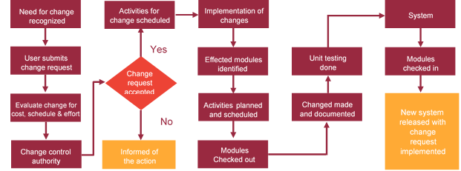

# Miscellaneous

## Acceptance Criteria

* UAT sign off should happen within 14 Days on release of the website and the acceptance confirmation needs to be mailed to Verbat failing which Verbat will consider the project as approved by the client.
* Any comments or reason for rejection need to be documented and the same needs to be sent as an email from the official mail id of client to Verbat.

## Warranty

* Verbat shall provide a bug ﬁx warranty at no additional cost for 30 days from the date of acceptance of the project, for correction of any errors in the developed application that may be attributed to Verbat.
* However, this does not cover modifications by Client, or use of the application on an environment other than the proposed environment, or other circumstances outside Verbat’s reasonable control. In such a case Verbat reserves the right to charge for its services.
* All error corrections will be executed at Verbat India office. In the event of any need for on-site work, all expenses incurred for such trips will be payable to Verbat by Client.

## General Terms and Conditions

* An average of 20 working days are assumed in a month
* All the projects activities will be carried out from our off-shore development center in India
* The scope of the project is to develop the Application as detailed in the scope of the project and mentioned in this proposal. Any changes or additions will have to go through change management.
* This proposal and all technical/ functional specifications have been derived or concluded from the data shared via email / information's transferred during the initial requirement analysis meetings and conversations. Verbat reserves the right to amend the terms of this proposal, should the SOW terms, functional features and functionalities change during the course of the project
* Application will be best viewed only in the environment mentioned in the section 9.1.2
* All the documentation will be provided in English.
* Third party components may be used to develop this application.
* All Source Code and other project artefacts would adhere to the Verbat document templates and internal coding standards
* Acceptance criteria shall be based on the clauses which were mutually discussed between Verbat and client at the Requirement Analysis phase and the same will be documented and approved by both parties through official emails
* In case Client requires any extension of the proposed acceptance schedule, the associated effort and cost of such extension can be mutually reviewed.
* For any circumstances if project needs to be put on Hold / Stop it requires minimum request notice period of 1 week along with duration for which request will be addressed by management and final decision on the request will be based on that
* If deployment is done in client’s server, Verbat cannot be held responsible for any performance issues arising due to hardware malfunctions.
* Client is responsible for data backup in case the application is not hosted on Verbat server.
* Source code will only be delivered or uploaded on the Production Server once the due payments are made.
* This proposal would have been derived or concluded from either the RFQ /RFP/data shared via email / information transferred during an initial requirement analysis meeting /tele-conversation. Verbat Technologies reserves the right to change the terms of this proposal as the final terms (including the costing), features & functionalities could change during the course of the project. Hence any fees quoted in this proposal may not be considered as the final cost of the project unless agreed and signed by both parties.

## Assumptions and Dependencies

* Detailed system study is required before the start of the project.
* During the requirement gathering phase, authorized personnel from the Client’s side is expected to be available for discussion and finalizing the HLD (High Level Design), before development commences.
* Type of reports and formats, if under the scope of the project, needs to be specified by Client before project sign off.
* Workflows if under the scope of the project, need to be specified/ confirmed by client before project signoff.
* All queries regarding the client requirement and any queries which may hinder the project advancement at any stage should be answered by the client within 24 hours from the time of initiation, failing which the time delay will get added to the actual effort which was estimated.
* Verbat assumes that all sign-offs from Client will be provided within agreed and specified timeframe.
* Client will provide all the necessary contents, both text and image, before starting the project in the format suggested by Verbat (if any).
* The client should provide the relevant information and data well in time for the execution of a related activity. Non- availability of this information or data may lead to an interruption of work which may result in a delay in delivery as well as additional costs to the client.
* Client should have/possess server with technical specifications as suggested by Verbat for the proposed application.

## Source Code & Intellectual Property Rights

* Upon completion of the Project and 100% completion of the payment, client will have access to the source code except for propriety codes, developer tools and third party application / modules like Microsoft Dynamics Products, Share Point LMS etc.
* The solution offered will be the intellectual property of the client and will be made available to the client on an “unlimited license” basis.
* Modifications by third party/person: No person or organization, other than Verbat or any person authorized by Verbat in writing, has any permission to modify/change the software Solution to be eligible to get continued support from Verbat as per the support terms defined under this document.
* Liabilities/Damages: Verbat accepts no liability or damages of any kind arising out of use or non-use of the software delivered. The responsibility of testing of software lies with Client.

## Maintenance & Support

Maintenance contracts by default are supported as per the basic SLA terms.

**AMC with Basic SLA is charged at 20 % of the total project value**. Additional Effort/change management request will be added towards Total Value of the Project to determine the AMC value.

Maintenance support is limited to providing application support for ensuring the consistency of the look-and-feel, bug fixes and user issues i.e. maintenance and support of the existing features of the application.

Support does not in any way cover providing technical or other support to the end users. The maintenance agreement does not include functionality changes or feature additions which are handled as change requests which will be charged AED 1200 per man day. AMC does not include server support, maintenance and application deployment.

AMC charges will cover Off-Site Support and Debugging. Support includes E-mail, Telephone and Chat unless explicitly specified. In the event, the application is hosted with the client; necessary remote desktop connectivity should be provided for carrying out maintenance activity.

Gap in AMC - In case if the client does not opt an AMC for a year and want to renew it after that period, 50% of the AMC amount for the year for which AMC is not taken will also be payable if the client wishes to renew the AMC contract.

Note:

* Please note that the AMC support shall start only after all the necessary sign-offs (AMC Document) to this effect have been given.
* It is not mandatory that the client should opt for an AMC. The client will still be supported on an ad-hoc basis on an agreed man-day rate.
* AMC Payment Terms: 100% to be paid as advance.

Service Level Agreement

|  |  |  |  |
| --- | --- | --- | --- |
| Key | Max Response Time | Max Resolution Time | Target |
| Basic | 1  working day | 3 working days | Request / incident / problem tickets. |
| Advanced | 5 Business Hours | 12 Business Hours | Request / incident / problem tickets. |
| Priority | 3 Business Hours | 5 Business Hours | Request / incident / problem tickets. |

Note:-

* We provide Basic SLA as standard with AMC while Advanced and Priority SLAs attract additional charges.
* Time zone applicable as per UAE time zones (4.00 AM GMT to 1.00 PM GMT- Sunday to Thursday).

## Our Clients

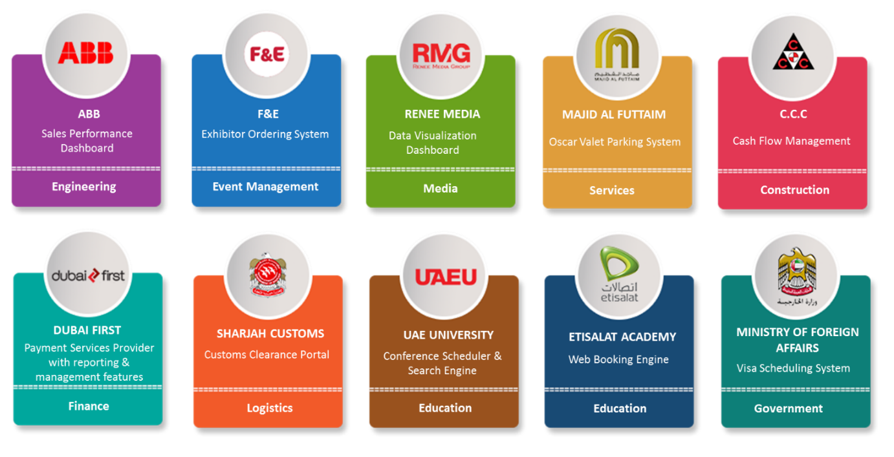

We look forward to hearing from you soon and hope that you will give us the privilege to work with you in meeting your business goals. Thank you.

Thank You



©   
1999 - 2017. All Rights Reserved   
Verbanet Technologies LLC  
www.verbat.com